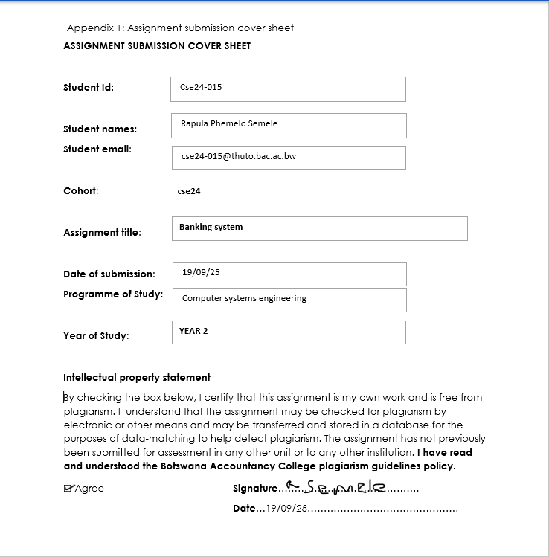

Requirements Elicitation
Functional requirements
- The system should be able to allow the user to login
- The system must validate the credentials
- The system should allow the customers to have more than one account if they wish to have them
- The bank system must implement interest every month for the savings account and the investment account
- The user must be able to check their balances
- The customer must be able to deposit money in to the accounts
- The user must be able to withdraw money from some of the accounts
- The system must be clear to the users in case of an error, the error specified accurately.
Non-functional requirements
- Security- the system must ensure that the user passwords are encrypted
- Reliability-the system must calculate the monthly interests accurately without data loss and errors
- Performance- it must take 2 seconds to login and the least time possible to navigate around the system application

UML Diagrams

Use case
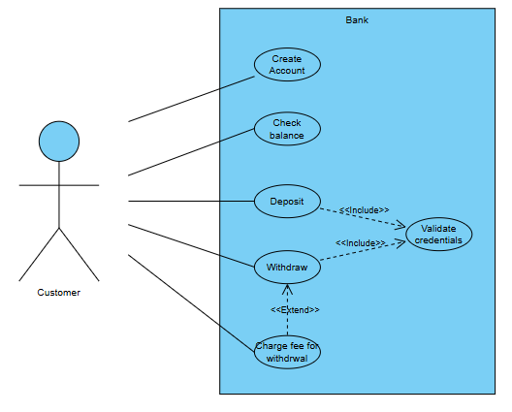

Class diagram
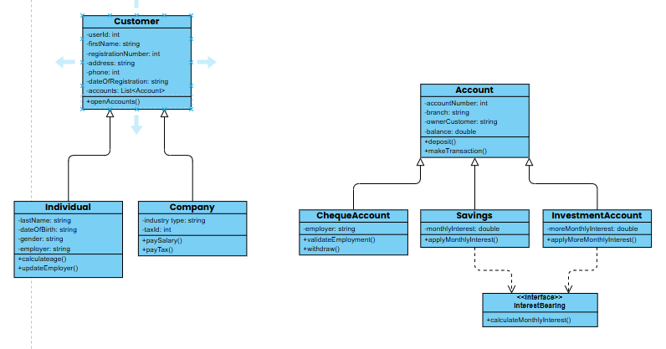

Sequence diagram

Open account
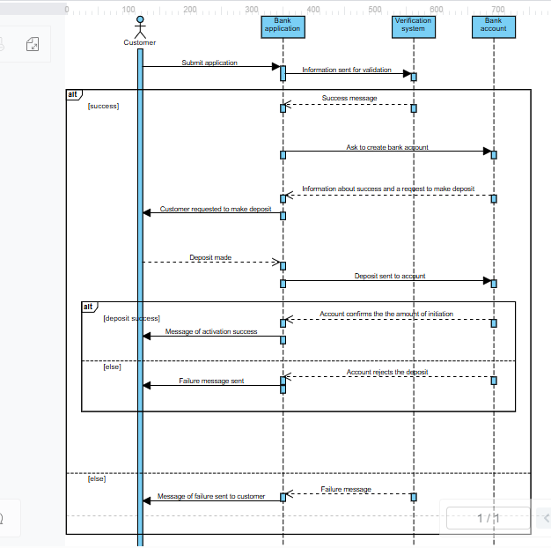

Login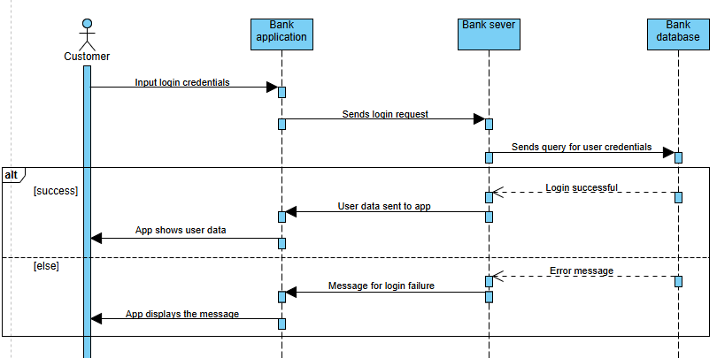

State diagram

Making transactions
